Contents
1. Introduction 3
2. System Architecture 4
2.1 Data Layer 4
2.2 Processing & Modelling Layer 4
2.3 Interface Layer 5
3. Implementation 5
3.1 Data Preprocessing Implementation 5
3.2 Exploratory Data Analysis (EDA) 6
3.3 Feature Engineering 6
3.4 Model Training and Model Evaluation 6
3.5 Model Persistence and Deployment 7
3.7 Implementation Flow Diagram 7
4. Challenges and Solutions 8
4.1 Data Quality and Noise 8
4.2 High Dimensionality of Text Data 8
4.3 Model Selection and Performance Trade-offs 9
4.4 Class Imbalance Concerns 9
4.5 Deployment and Dependency Issues 9
4.6 User Interface Simplicity and Interpretability 9
5. Results and Application Demonstration 9
5.1 Web Application Demonstration 10
5.3 Exploratory Visual Results 13
5.4 Practical Implications 13
6. Conclusion and Future Work 14
6.1 Conclusion 14
6.2 Future Work 14
References 15

Figures
Figure 1 Implementation Flow diagram 8
Figure 2 Spam Email Detector Spam Identified Screenshot 10
Figure 5 Spam Email Detector Not Spam Identified Screenshot 11
Figure 6 Classification method and Confusion matrix 12
Figure 7 Bar chart For Spam v not Spam Distribution 13

1. Introduction
The communication through emails is presently the principal means of transferring information both in business and personal communications in the digital world of today. However, the fast growth in the use of emails has given birth to the scourge of spam emails that has turned into a nightmare for individuals and businesses alike. Spam emails are basically those which are sent out in huge numbers ignoring the will of the recipients, and they not only block communication but also pose threats like phishing, malicious attachments, fraudulent offers, or even viruses. The unsolicited emails can lead to money loss, identity theft, privacy invasion and all these plus a decrease in productivity (Ahmed et al., 2022; AbdulNabi & Yaseen, 2021).
Objective
The project aims at designing a machine learning-based platform that will be capable of accurately and systematically identifying spam emails and showing results through a user-friendly web application. Natural Language Processing (NLP) techniques will be used by the platform for text preprocessing, TF-IDF (Term Frequency-Inverse Document Frequency) for feature extraction and a Logistic Regression model for classification(AbdulNabi & Yaseen, 2021).
With the fusion of these methodologies, the platform is anticipated to deliver an accurate, scalable, and adaptable solution to the perennial issue of spam detection.
Significance of the Solution
The spam detection system created in this project has several implications, both practical and academic:
- The automatic detection and filtering of unwanted or harmful emails significantly reduce the risk of phishing attacks and the dissemination of malware.
- The users will not have to devote so much time to the processing of emails that are of no concern to them, and hence will be able to give more time to performing the essential tasks.
- The project not only demonstrates the application of natural language processing but also machine learning techniques in solving one of the largest cybersecurity issues in real life.
The approach can be used for language spam detection, connecting it with the corporate email systems, and improving the accuracy through the use of deep learning models (Siddique et al., 2021; Uddin, Mahiuddin & Sarker, 2024)

2. System Architecture

2.1 Data Layer
The Data Layer is the fundamental layer of the system. Its functions include getting, storing and cleaning data. To carry out the project, a dataset that is publicly accessible is being used. The dataset contains 193,850 emails, each of which is assigned a label. The two labels are 'spam' and 'ham' (non-spam). The model will be trained with this dataset which is quite large and contains varied and diverse email contents, thus it will be able to generalize well to unseen data.
Data preprocessing is a very important step in Natural Language Processing (NLP) tasks because the raw email text usually contains noise, redundant information, and irrelevant symbols (Aggarwal, 2018). The authors applied the following cleaning steps to the data:
- Remove missing values in order to keep the integrity and consistency of the dataset.
- All text is converted to lowercase to make uniformity so that no two representations will be counted as one for the same word.
- Using regular expressions, the authors disallowed the presence of email addresses, URLs, numbers, punctuation, and special characters, thus eliminating irrelevant patterns.
- Using the NLTK stopword corpus, stop words removal was done. This was to make the noise less and to highlight the semantically meaningful terms.
- Whitespace normalization and tokenization were done to make the text input uniform in all respects.

2.2 Processing & Modelling Layer
The Processing and Modelling Layer has the task of turning the cleaned email text into numeric forms and teaching the machine learning model for classification. The reason being that the machine learning algorithms are not capable of handling text data directly, thus the text from the emails is converted into numerical feature vectors with the help of TF-IDF (Term Frequency–Inverse Document Frequency) vectorization.
TF-IDF will give more weight to the words that occur frequently in a single email but are less common in the whole set of emails, thus it is very useful in text classification tasks like spam detection (Salton & Buckley, 1988). Where a limit is set by using the parameter max_features = 5000; thus, only the 5000 least features are kept for the class cation and these are the most informative ones while there are also the advantages of reduced computation and no overfitting.
A Logistic Regression model is used in the case of classification which gives the result of binary classification of the texts (spam or non-spam). The data set comprises 80% of the total emails for training purposes and 20% for testing thus making sure the approach to learning and evaluation is unbiased.
The model's performance is assessed using common classification metrics like accuracy, precision, recall, and F1-score which when put together give a thorough evaluation of the prediction quality and strength and especially in dealing with class imbalance. At last, to make the deployment of the trained TF-IDF vectorizer and Logistic Regression model using the joblib library serialization, both the trained TF-IDF vectorizer and the Logistic Regression model are serialized thereby fast and reliable inference within the web-based application without the hassle of retraining is possible.

2.3 Interface Layer
The Interface Layer gives users the ability to interact with and make predictions in real time via a web application based on Streamlit. Streamlit was chosen because of its easy-to-use nature, fast deployment options, and it being a good fit for machine learning demos.
The interface has the following main features:
- A text input box where you can write the content of the email
- Real-time classification output (Spam or Not Spam)
- A probability score that is meant to increase transparency and in turn trust from the user
- Instant inference through the backend integration of the saved model and vectorizer

3. Implementation

3.1 Data Preprocessing Implementation
The first step of the implementation is to load the data into memory with the help of the Pandas library. The dataset's core features are the email content and its respective label (either spam or non-spam). Any textual data with missing or null values is discarded from the dataset in order to maintain data quality.
A specific text cleaning method is developed to bring the email content to one standard. The method executes a number of preprocessing tasks which include converting the text to lowercase, deleting URLs, email addresses, numbers, and punctuation symbols, and eliminating extra spaces. Also, NLTK stop words are discarded in order to minimize noise and highlight the informative terms. These steps are very important as they lead to the extraction of better-quality features from the text data and eventually to better model performance.
The text after cleaning is kept in a new column and is also output as a separate CSV file for the sake of reproducibility and to make it available for use in future experiments.

3.2 Exploratory Data Analysis (EDA)
Data exploration is the very first step of model building, it is done to check the distribution of spam and non-spam mails. A bar chart showing the distribution of classes is created for this purpose, which helps to find out class imbalance if there is any. Even though the dataset is quite balanced, the visual confirmation has been done to support the modelling decisions made.
Along with that, word clouds for spam and non-spam emails are also prepared. These images point out the most frequently used words and show typical trends like the use of promotional language in spam emails and the use of casual language in legitimate emails.

3.3 Feature Engineering
Machine learning models need numerical input; therefore, the clean text is converted using TF-IDF Vectorization. The Scikit-learn is set with 5,000 features maximum in order to provide a good compromise between the model's expressiveness and its computational efficiency.
The data is divided into one training part (80%) and one testing part (20%) with the help of a random seed that is fixed to allow the results to be verified.

3.4 Model Training and Model Evaluation
A Logistic Regression classifier is used for the binary classification task. This method is excellent for high-dimensional sparse data like TF-IDF vectors and offers strong baseline performance on text classification tasks (Mansoor et al., 2021).
The model is fitted with training data transformed using TF-IDF. To keep it simple and interpretable, default hyperparameters are used and at the same time, high classification accuracy is reached.
Using various performance metrics, the evaluation of the model has been done on the test dataset. To measure the total correctness, Accuracy is calculated, on the other hand, precision, recall, and F1-score help to understand the model's capability of spam email detection more clearly.
A confusion matrix is created and depicted using a heatmap to show true positives, true negatives, false positives, and false negatives. This graphic representation aids in the evaluation of misclassification trends and supports the claim of the classifier's strength. The final model reaches an accuracy of nearly 97%, indicating a powerful predictive ability.

3.5 Model Persistence and Deployment
Following a successful evaluation, the Logistic Regression model which was trained together with the TF-IDF vectorizer, are saved in the joblib library. The artifacts that have been saved are then incorporated into a web application based on Streamlit, where users can type in the text of an email and get predictions instantly.
The application at runtime loads the model and vectorizer that have been trained, user input is then pre-processed and the result of the classification along with the confidence score is displayed.

3.7 Implementation Flow Diagram
The entire process of implementation is represented in the flowchart below:

Figure 1 Implementation Flow diagram

4. Challenges and Solutions

4.1 Data Quality and Noise
Email datasets generally possess a lot of noise like HTML tags, URLs, random characters, numbers and informal language. If not managed effectively, such noise can have an adverse effect on feature extraction along with model performance.
A thorough text preprocessing pipeline was set up making use of regular expressions and NLP techniques. The pipeline got rid of URLs, email addresses, numbers, punctuation, and extra whitespace. Furthermore, stop words were excluded by using the NLTK stop words corpus in order to direct the model to semantically significant words. These procedures led to great improvement in feature quality and thus contributed to the overall increase in classification accuracy.

4.2 High Dimensionality of Text Data
Text data is very often accompanied by high-dimensional feature spaces, which may raise computational expenses and cause overfitting as well. TF-IDF vectorization with a maximum feature size of 5000 was used. This method kept the words that were the most informative and at the same time reduced the dimensionality. Logistic Regression was opted for as it does good on sparse, high-dimensional datasets and is thus able to generalize well.

4.3 Model Selection and Performance Trade-offs
The selection of a suitable machine learning model was determined by the trade-off between interpretability, accuracy, and computational efficiency. The deep learning architectures as more complex models require significantly higher computational power and longer training times.
Due to its simplicity, rapid training time, and solid performance in text categorization tasks, Logistic Regression was selected as a strong baseline model. The model, although simple, obtained about 97% accuracy, thus proving that classical machine learning approaches are still quite effective for spam detection problems (Siddique et al., 2021) despite the advancements in other areas.

4.4 Class Imbalance Concerns
Datasets for spam detection can be plagued by class imbalance, wherein one class is much larger than the other, leading to skewed model predictions. Through the EDA, it was revealed that the dataset had approximately the same number of instances in both classes.

4.5 Deployment and Dependency Issues
Deployment caused issues with missing libraries like NLTK, mismatched versions, and incompatibility between the models, especially when one was migrating from Jupyter Notebook to Streamlit application.
The whole list of dependencies was clearly specified and installed in a controlled Python environment. The model and vectorizer were saved with joblib, making sure of their compatibility and saving them from having to be retrained in deployment. This method allowed the machine learning pipeline and web application to work together perfectly.

4.6 User Interface Simplicity and Interpretability
A very straightforward and user-friendly interface was created using Streamlit. Through it, a user simply types a text in a small field, gets a clear reply of either spam or non-spam, and also sees the probability scores which are meant to make the whole system more transparent and be trustworthy for the users.

5. Results and Application Demonstration
This section presents the experimental results obtained from the machine learning model and demonstrates the functionality of the deployed Spam Email Detection Web Application.

5.1 Web Application Demonstration
A Streamlit-based web application was created which incorporates the trained model. The web app makes it possible for the users to write an email and get a classification outcome right away. for the application the workflow was like this:
- The user pastes the text of the email in the input area.
- The text goes through the same cleaning of preprocessing as during training.
- The input text is turned into numerical features through TF-IDF vectorization.
- The trained Logistic Regression model is the one that predicts the spam or non-spam category of the email.
- The output is then shown along with the probability score.
One might think of a case where the text “Hi got $100 free chance to win.” was inputted by the user, the application would classify it as spam and would also give the classification a high confidence level.
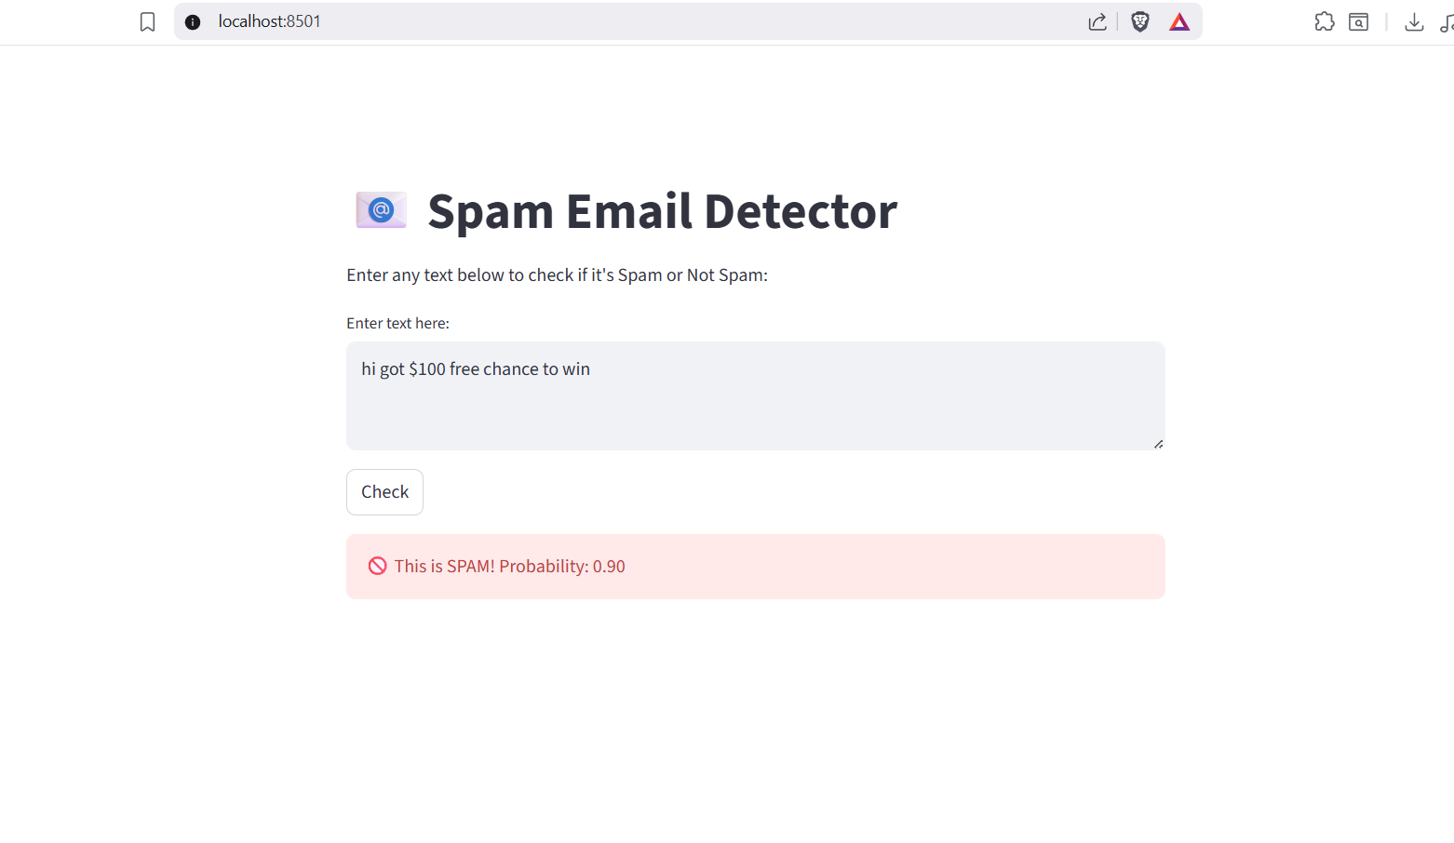
Figure 2 Spam Email Detector Spam Identified Screenshot
Another case where the text “Hi I have work with you” was inputted by the user, the application would classify it as this is not spam.

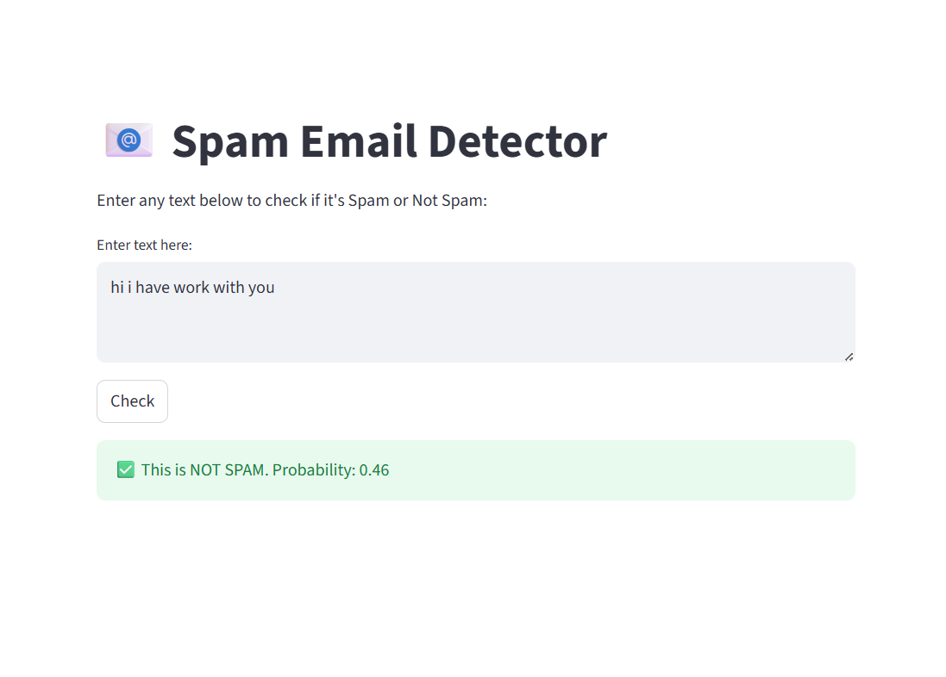
Figure 3 Spam Email Detector Not Spam Identified Screenshot
5.2 Model Performance Evaluation
The Logistic Regression model was fed with 80% of the dataset (155,080 emails) and the rest 20% (38,770 emails) were used for evaluation. Using the standard classification metrics, a thorough evaluation was made to offer a complete assessment.
Performance Metrics:
• Accuracy: 97.34%
• Precision (Spam): 0.97
• Recall (Spam): 0.98
• F1-Score (Spam): 0.97
The indicated results underscore the fact that the model is extremely proficient in telling apart spam and non-spam emails. The high recall score is a clear indication of the system’s capability to recognize correctly the majority of spam emails, which is very important for security-sensitive applications. In the same way, the robust precision score tells us that the model keeps false positives to the minimum, thus ensuring that legitimate emails are not wrongfully identified as spam.
To aid the understanding of the classification outcomes, a confusion matrix was created. The matrix reveals a large number of correct predictions along the diagonal, thereby confirming the strength of the model that was trained.
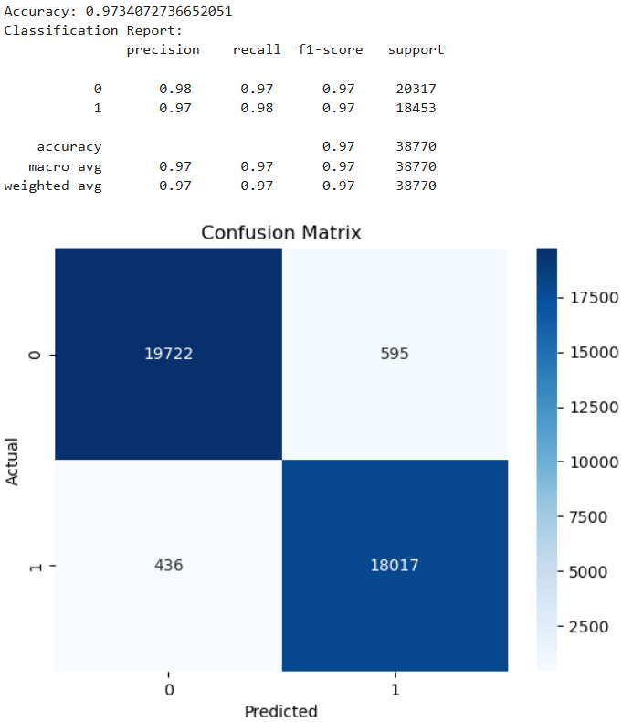
Figure 4 Classification method and Confusion matrix

5.3 Exploratory Visual Results
To better understand the data and the classification model behaviour, various graphics were created for the purpose:
- Spam vs Non-Spam Distribution Plot:
The plot illustrates a more or less even distribution of spam and non-spam emails, thus helping to assure the training of the model is stable.
- Word Clouds:
Separate word clouds were made of both spam and non-spam emails.
Spam emails were mainly composed of promotional, financial, and urgent terms along with such words as winning, free, offering, etc. In contrast, non-spam emails contained words mostly of a conversational and contextual nature, thus indicating corresponding communication.
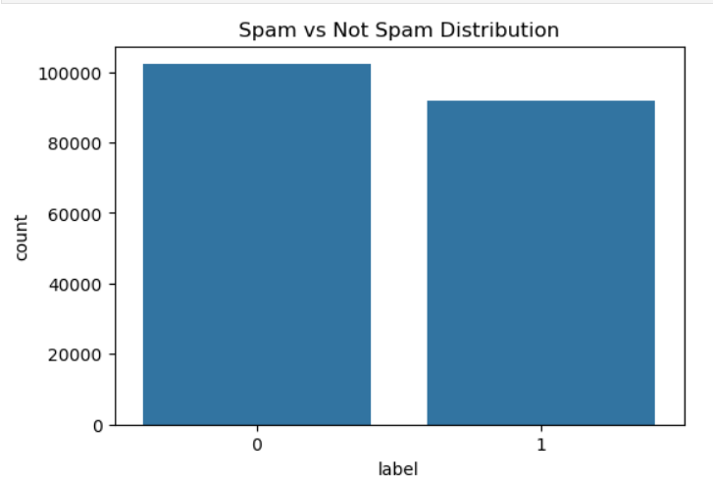
Figure 5 Bar chart For Spam v not Spam Distribution
The illustration displays how both spam and non-spam emails are categorized in the dataset. It indicates that the two classes are quite well balanced, although there are a few more non-spam emails (label 0) than spam emails (label 1).
Such a balanced distribution is advantageous for machine learning because it minimizes the possibility of model bias in Favor of one class and at the same time allows the classifier to learn the features of both spam and legitimate emails effectively. Thus, the model can perform stably without the need for complex methods to counteract class imbalance.

5.4 Practical Implications
The findings show that the system created is dependable, fast, and ready for use in everyday situations. Being highly accurate and having the ability to predict in real-time makes it possible to use the system for filtering personal emails, securing enterprises, and teaching students about machine learning through demonstrations in practice.

6. Conclusion and Future Work

6.1 Conclusion
The Spam Email Detection Web Application project using machine learning techniques has been completed. The system was successful in differentiating between spam and real emails at a high accuracy rate through Natural Language Processing (NLP) methods and a Logistic Regression classifier. The project provided an efficient, automated, and user-friendly solution for email spam detection, thus addressing a common problem in digital communications.
TF-IDF vectorization contributed to raw text feature extraction, while Logistic Regression was a model that worked efficiently and could be understood for binary classification. A remarkable 97.34% accuracy score, together with high precision, recall, and F1-scores, indicates that the proposed method is robust and trustworthy. Even more, the implementation of the trained model in a Streamlit web application allowed for instant forecasts and improved user engagement.
To sum up, the project is a testament to the role of machine learning in cybersecurity and information filtering, emphasizing the aspects of data preprocessing, model selection, and performance evaluation as critical in the development of an efficient intelligent system.

6.2 Future Work
Even though the existing system is up to the mark, there are still many improvements that can be made to increase the application's functionality and scalability.
- Advanced Models:
One way to go forward with the experimentation is to try deep learning models like LSTM, CNN, or transformer-based (BERT) which can clearly understand the context and semantics very well.
- Multilingual Spam Detection:
The system would be more useful if it could detect and process multiple languages at a time; this would be the case when dealing with global email services/platforms.
- Explainable AI (XAI):
By means of applying explaining methods like SHAP or LIME, it would be possible for the users to comprehend the reasons behind the spam email classification, thus boosting the system's transparency and trust from users' side.
- Real-Time Email Integration:
The solution can be coupled with email servers via APIs (e.g. Gmail or Outlook) for filtering of spam emails in an automatic manner.
- Continuous Learning:
With online learning or retraining at intervals, the model would be able to adjust itself to the changes in spam patterns as well as the attackers’ new strategies.

References
Ahmed, N., Amin, R., Aldabbas, H., Koundal, D., Alouffi, B. and Shah, T., 2022. Machine learning techniques for spam detection in email and IoT platforms: analysis and research challenges. Security and Communication Networks, 2022(1), p.1862888.
AbdulNabi, I.A. and Yaseen, Q., 2021. Spam email detection using deep learning techniques. Procedia Computer Science, 184, pp.853-858.
Atlam, H.F. and Oluwatimilehin, O., 2022. Business email compromise phishing detection based on machine learning: a systematic literature review. Electronics, 12(1), p.42.
Debnath, K. and Kar, N., 2022, May. Email spam detection using deep learning approach. In 2022 international conference on machine learning, big data, cloud and parallel computing (COM-IT-CON) (Vol. 1, pp. 37-41). IEEE.
Jain, V., 2025, April. Intelligent Email Spam Detection: A Machine Learning-Based Approach. In 2025 5th International Conference on Trends in Material Science and Inventive Materials (ICTMIM) (pp. 1574-1579). IEEE.
Mansoor, R.A.Z.A., Jayasinghe, N.D. and Muslam, M.M.A., 2021, January. A comprehensive review on email spam classification using machine learning algorithms. In 2021 International conference on information networking (ICOIN) (pp. 327-332). IEEE.
Salloum, S., Gaber, T., Vadera, S. and Shaalan, K., 2022. A systematic literature review on phishing email detection using natural language processing techniques. Ieee Access, 10, pp.65703-65727.
Siddique, Z.B., Khan, M.A., Din, I.U., Almogren, A., Mohiuddin, I. and Nazir, S., 2021. Machine Learning‐Based Detection of Spam Emails. Scientific Programming, 2021(1), p.6508784.
Uddin, M.A., Mahiuddin, M. and Sarker, I.H., 2024. An explainable transformer-based model for phishing email detection: A large language model approach. arXiv preprint arXiv:2402.13871.

